Randoop.NET developer notes
Randoop.NET version Beta 1.1
Author: Carlos Pacheco, Shuvendu Lahiri, Tom Ball

1. Building the sources 1
2. Randoop.NET Design 1
3. Code highlights 3
4. Tips for debugging problems in Randoop 3

Warning: The sections are partial and mostly incomplete!!

Building the sources
- Open the Randoop2.sln file in VS2008
- Set the configuration to either Debug or Retail
- Go to Build
  - Clean Solution
  - Build Solution
- The executable will reside in (for the Debug build) in
  - Randoop\bin\debug\randoop.exe

NOTE: When the Retail version is built, the directory ZipFolder\randoop contains a drop with all the binaries.

Randoop.NET Design

Note: this section is still being written.

Architecture. Randoop.NET is actually a thin shell around RandoopBare, which is the program that actually generates tests.
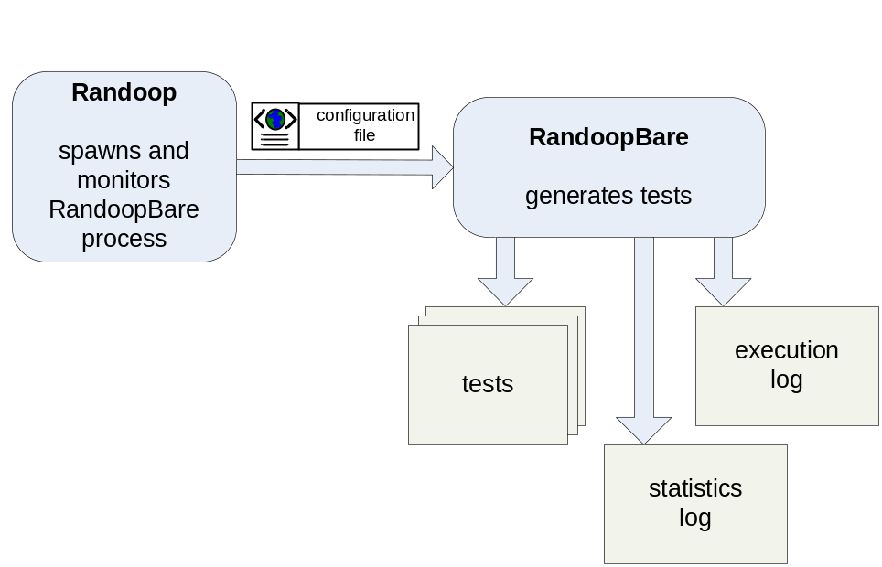

When you invoke Randoop, you specify an amount of time T to generate tests (see /timelimit:N). Randoop.NET performs the following steps.

- Parse command-line arguments.
- Create an XML configuration file. The file contains the values for all the parameters that RandoopBare requires (this includes parameters parsed from the command line, but also includes other generation parameters not given by the user, such as the location of default configuration files).
- Invoke RandoopBare, passing it the XML configuration file.
- Wait for N seconds for RandoopBare to terminate (see /restart:N, default=100 seconds).
- If RandoopBare has not terminated, kill it forcefully.
- If the total generation time limit T has not expired, invoke RandoopBare again, passing it a new configuration file with a different random seed. Go to step 4.
- When the total generation time limit T has expired, collect all the generated tests, summarize them, and present the results to the user.

As the above steps suggest, one run of Randoop.NET may actually consist of several runs of RandoopBare. For example, if you specify the total time limit T to be 1000 seconds, then Randoop.NET may invoke RandoopBare 10 times, each with a different random seed. We do this for two reasons. First, RandoopBare is executing random code, and sometimes this causes it to crash (e.g. if it creates a test case that leads to an access violation, RandoopBare may be forcefully terminated). If the total time limit has not expired, then to do progress and continue generating tests Randoop.NET invokes RandoopBare again, which generates more tests. To prevent it from generating the same exact tests as the last invocation, Randoop.NET passes a different random seed to the new invocation of RandoopBare.

The second reason why Randoop.NET kills RandoopBare at regular intervals is that RandoopBare’s performance degrades as it generates and executes more tests; starting a new process regularly guarantees that the generation process does not slow down to a crawl.

RandoopBare. The test generator is RandoopBare. (You can actually invoke RandoopBare directly; its single argument is an XML configuration file. See class Randoop. RandoopConfiguration.) RandoopBare repeatedly performs the following steps.

- Generate a new sequence of API calls for the code under test.
- Write the sequence out to file (as a C# program).
- Execute the sequence.
- Classify the result of the execution (normal, exception-throwing, etc.).

Also, as RandoopBare executes, it logs out information to a statistics and an execution log, which are also files.

Code highlights

Test representation. [TODO]

Action (aka Transformers). [TODO]

Test generation. [TODO]

Running tests for Randoop. [should move to NUnit]. [Beware tests sometimes fail due to some file deletion error that does not mean an error in Randoop.]

Where do auxiliary tools live? Common.TestCaseUtils

You can run Randoop.NET from bin\Debug\randoop.exe, or you can unzip randoop.zip and run from bin\randoop.exe. The Common.Environment static initializer figures out which of these two you’re running, and sets things up accordingly.

Known bugs. Null passed implicitly. Code generation (Scott reported it).
Contact Shuvendu, he’ll be very helpful in debugging the problem.

Currently execution log does nothing.

Tips for debugging problems in Randoop

Test generation bugs. [TODO]

Repro code generation bugs. [TODO]

Randoop.TestWriterHelperMethods.WritePlanToFile method, change

code = p.ToTestCase(exceptionThrown, false, className);

to

code = p.ToTestCase(exceptionThrown, true, className);

This will cause a comment to be printed out with each test…

